Year 7 Art & Design – POP ART
In this project you will be learning about the Art Movement: Pop Art. Within the project you will develop your drawing skills and use of colour. The project will result in a juxtaposition of packaging and brand logos influenced by artists such as Andy Warhol and Roy Lichtenstein.

Objectives:
- To be able to use the formal elements successfully when drawing from observation. These include scale, proportion, shape and tone.
- To show knowledge and understanding of colour theory.
- To be able to describe & analyse the key characteristics of Pop Art.
- To be able to evaluate critically the success and developments required in their own work and the work of others.

Learning outcomes:
Enlarged pencil drawing
Pencil crayon study
Roy Lichtenstein study
Literacy assessment
Final outcome

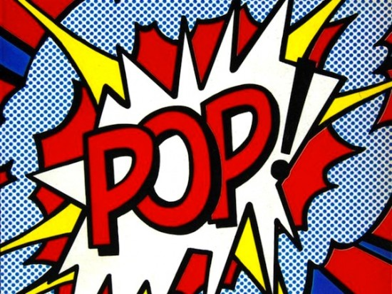
Commercialism

Independent learning:
Title Page/ Front cover
Literacy task
Andy Warhol colouring task
Extended homework task inspired by Andy Warhol.

Useful websites:
https://www.pinterest.com/medenschool/
http://www.tate.org.uk/learn/online-resources/glossary/p/pop-art
http://www.theartstory.org/movement-pop-art.htm

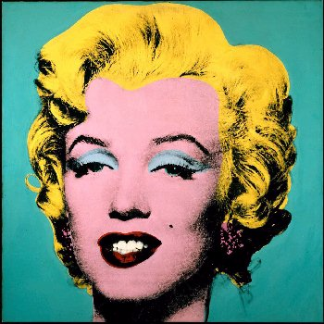
Keywords:
Shape, proportion, enlarged, colour, benday dots, commercialism, packaging, brands, logos, juxtaposition, media, society, America, 1950’s.

“In the future everybody will be famous for 15 minutes.”
Andy Warhol

0 | 5 | 6 | 8 | 10 | 13 | 16 | 20 | 23 | 26 | 30

