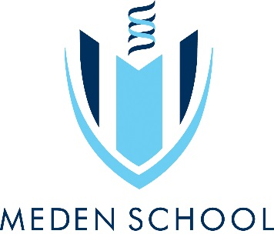
Year 8 Art & Design
In this project you will be developing your observational drawing skills by looking at natural forms. You will also be analysing artists that have been inspired by the natural world and develop your printmaking & painting skills in producing your own response.

Objectives:
- To learn about the qualities of different drawing materials and the importance and relevance of different approaches to drawing.
- To understand the principles of block printing and to be able to achieve a good quality polystyrene/press print
- You will be able to analyse and research the work of others and recognise key characteristics of their work.
- You will learn how to develop an idea to produce a range of successful outcomes.

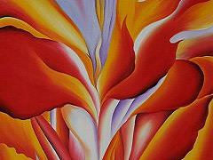
Learning outcomes:
Pencil Drawing
Viewfinder drawings
Artist copy ( Karl Blossfeldt)
Press Print outcome
Artist copy (Georgia O’Keefe)
Painting outcome

Natural World
Independent learning:
Title Page/ Front cover
Photos or images of natural forms
Research & analysis into or Karl Blossfeldt
Texture worksheet
Research & analysis into Georgia O’Keefe

Useful websites:
https://www.pinterest.com/medenschool/
www.karlblossfeldtphotos.com/
www.whitechapelgallery.org/exhibitions/karl-blossfeldt/
www.angielewin.co.uk/

Keywords:
Layers, printmaking, natural, form, shade, tone, proportion, scale, line, texture, mark making, Angie Lewin, Karl Blossfeldt, shape, foreground, background, middle ground, drawing, develop, analyse, reflect.
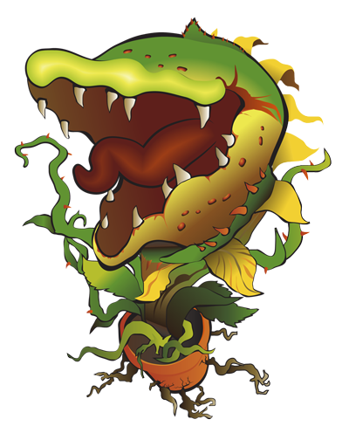

FEED ME!

10 | 13 | 16 | 20 | 23 | 26 | 30 | 33 | 36 | 40

