In this project you learn about the course structure in GCSE Art and how to use a sketchbook effectively. You will also be exploring all the processes required to meet the 4 Assessment objectives, including recording, refining, analysing and presenting. The project is Fragmentation & Distortion, which you will be exploring throughout the year, his term you will focus on still life objects. You will develop your drawing skills and learn about the Art Movement Cubism.
Year 9 - Fragmentation & Distortion

Objectives:
AO1 – be able to analyse, compare and form your own opinions about the work of others and recognise key characteristics of Cubist artwork.
AO2 – you will be able to experiment and explore a range of materials, processes and techniques in developing and refining your own ideas around the given theme.
AO3 – you will learn how to record effectively through use of drawing, photography and annotation.
AO4 – You will present your work in an orderly and effective way to document your journey.

Learning outcomes:
Mind Map
Range of observational drawings & colour studies
Still life pencil drawing
Net drawing
Response to analytical cubism
Response to Synthetic cubism
Cubism analysis
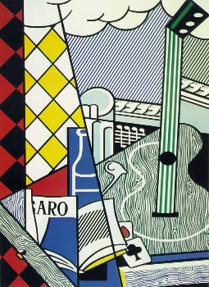
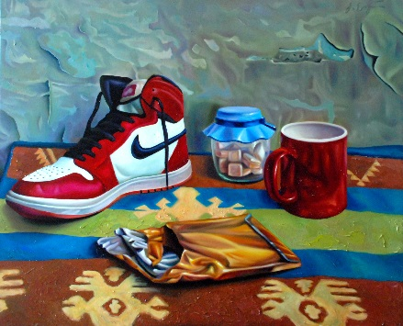
Still Life

Useful websites:
https://www.pinterest.com/medenschool/
www.artmovements.co.uk/cubism.htm

Independent learning:
Title Page/ Front cover
Mood board
Photos of still life arrangements
Digital / manual manipulation of photos
Cubism research
Artist copy of Analytical Cubism
Artist copy synthetic cubism
Assessment:
Each of the 4 assessment objectives are marked out of 18, giving you a total mark out of 72.

AO1 | AO2 | AO3 | AO4 | Final Mark

No masterpiece was ever created by a lazy artist!

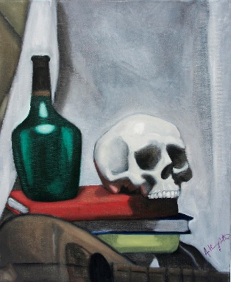
Keywords:
Record, present, refine, develop, explore, experiment, reflect, contextual, analyse, compare.
Fragment, distort, change, alter, blur, smudge, rearrange, twist, layer, pixelate.

