In this project you learn about the course structure in GCSE Art and how to use a sketchbook effectively. You will also be exploring all the processes required to meet the 4 Assessment objectives, including recording, refining, analysing and presenting. The project is Fragmentation & Distortion, which you will be exploring throughout the year, this term you will focus on portraiture. You will develop your drawing skills and learn about how colour can reflect a mood.
Spring Term (Jan – April)

Objectives:
AO1 – be able to analyse, compare and form your own opinions about the work of others and recognise key characteristics of a portrait artist’s work.
AO2 – you will be able to experiment and explore a range of materials, processes and techniques in developing and refining your own ideas around the given theme.
AO3 – you will learn how to record effectively through use of drawing, photography and annotation.
AO4 – You will present your work in an orderly and effective way to document your journey.

Learning outcomes:
Range of drawings of the features of the face
Self-portrait in pencil
Fragmented portraits (manual manipulation of photos)
Mixing skin tones.
Chuck Close Responses
Extension: Henry Mee responses.
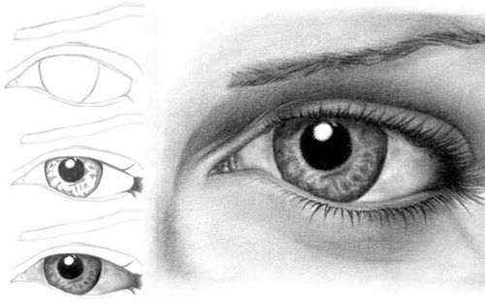
Portraiture

Useful websites:
https://www.pinterest.com/medenschool/
https://www.artspan.com/portraiture

Independent learning:
Mood board/ title page
Photos
Digital manipulation of photos
Chuck Close Research & Analysis
Chuck Close Artist Copy
Independent Artist research
Independent Artist response.

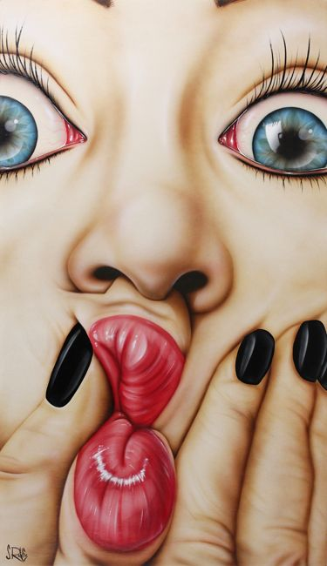

Every job is a self-portrait of the person who did it. Autograph your work with excellence.

Every job is a self-portrait of the person who did it. Autograph your work with excellence.

Keywords:
Record, present, refine, develop, explore, experiment, reflect, contextual, analyse, compare.
Fragment, distort, change, alter, blur, smudge, rearrange, twist, layer, pixelate.

Keywords:
Record, present, refine, develop, explore, experiment, reflect, contextual, analyse, compare.
Fragment, distort, change, alter, blur, smudge, rearrange, twist, layer, pixelate.
AO1 | AO2 | AO3 | AO4 | Final Mark

Assessment:
Each of the 4 assessment objectives are marked out of 20, giving you a total mark out of 80.
Grade Boundaries: (As a guide)
D= 35 C= 45 B=56 A=67 A*=73

AO1 | AO2 | AO3 | AO4 | Final Mark
Each of the 4 assessment objectives are marked out of 20, giving you a total mark out of 80.
Grade Boundaries: (As a guide)
D= 35 C= 45 B=56 A=67 A*=73

