Year 8 Art & Design
In this project you will be developing your observational drawing skills by looking at portraiture. The project will also build on your understanding of colour theory through exploring the work of the Fauvist Art Movement.

Objectives:
- To learn about the qualities of different drawing materials and the importance and relevance of different approaches to drawing.
- To show knowledge and understanding of colour theory and making connections to use of colour to express a mood or emotion.
- You will be able to analyse and research the work of others and recognise key characteristics of their work.

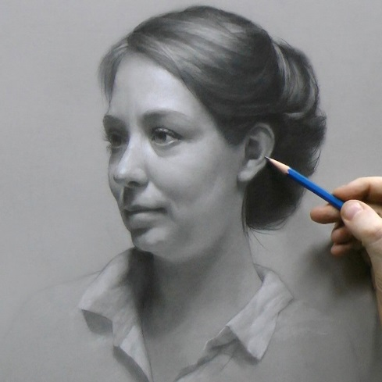
Learning outcomes:
Drawings of the features of the face.
Self portrait
Tonal Study
Henry Mee Response
Oil Pastel study
Fauvist self-portrait (FINAL OUTCOME)

Portraiture
Independent learning:
Title Page/ Front cover
Drawing the Eye
Literacy Task
Henry Mee Analysis
Fauvism Analysis

Useful websites:
https://www.pinterest.com/medenschool/
http://www.theartstory.org/movement-fauvism.htm
http://www.henrymee.com/
http://www.henri-matisse.net/

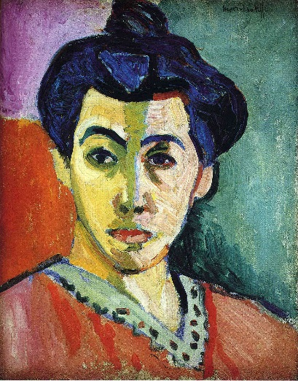
Keywords:
Symmetry, colour, tone, shape, mark making, emotions, feelings, bright, bold, contrasting, Portraiture, features of the face, proportions, scale, mood, unrealistic.
“The chief function of colour should be to serve expression”
Henri Matisse

10 | 13 | 16 | 20 | 23 | 26 | 30 | 33 | 36 | 40

