In this project you learn about the course structure in GCSE Art and how to use a sketchbook effectively. You will also be exploring all the processes required to meet the 4 Assessment objectives, including recording, refining, analysing and presenting. The project is Fragmentation & Distortion, which you will be exploring throughout the year, this term you will focus on landscapes & architecture. You will develop your drawing skills and learn about perspective.
Summer Term (April – July)

Objectives:
AO1 – be able to analyse, compare and form your own opinions about the work of others and recognise key characteristics of John Piper’s and Charles Sheeler’s work.
AO2 – you will be able to experiment and explore a range of materials, processes and techniques in developing and refining your own ideas around the given theme.
AO3 – you will learn how to record effectively through use of drawing, photography and annotation.
AO4 – You will present your work in an orderly and effective way to document your journey.

Learning outcomes:
Fragmented drawings in a range of materials.
Larger pencil drawing
John Piper response
Charles Sheeler response
Development of Ideas
Final outcome
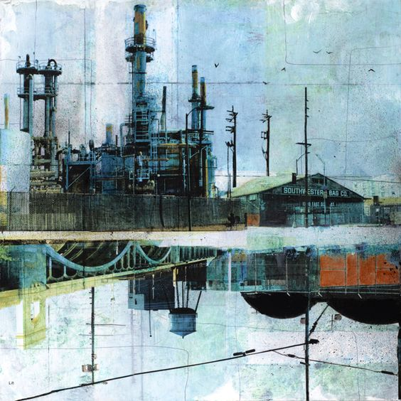
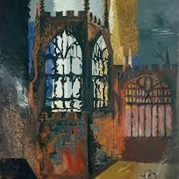

Landscapes & Architecture

Useful websites:
https://www.pinterest.com/medenschool/
https://www.architecture.com/Explore/Home.aspx

Independent learning:
Mood board/ title page
Looking through drawing in pencil
Photos
Digital manipulation of photos
Assessment revision & practise
John Piper Research & Analysis
Charles Sheeler Research & Analysis

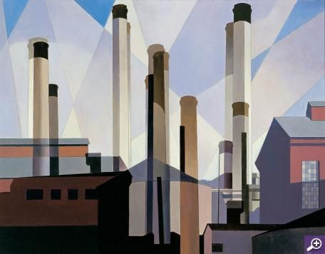

If a building becomes architecture then it becomes art.

AO1 | AO2 | AO3 | AO4 | Final Mark
Assessment:
Each of the 4 assessment objectives are marked out of 20, giving you a total mark out of 80.
Grade Boundaries: (As a guide)
D= 35 C= 45 B=56 A=67 A*=73

AO1 | AO2 | AO3 | AO4 | Final Mark
Each of the 4 assessment objectives are marked out of 20, giving you a total mark out of 80.
Grade Boundaries: (As a guide)
D= 35 C= 45 B=56 A=67 A*=73

